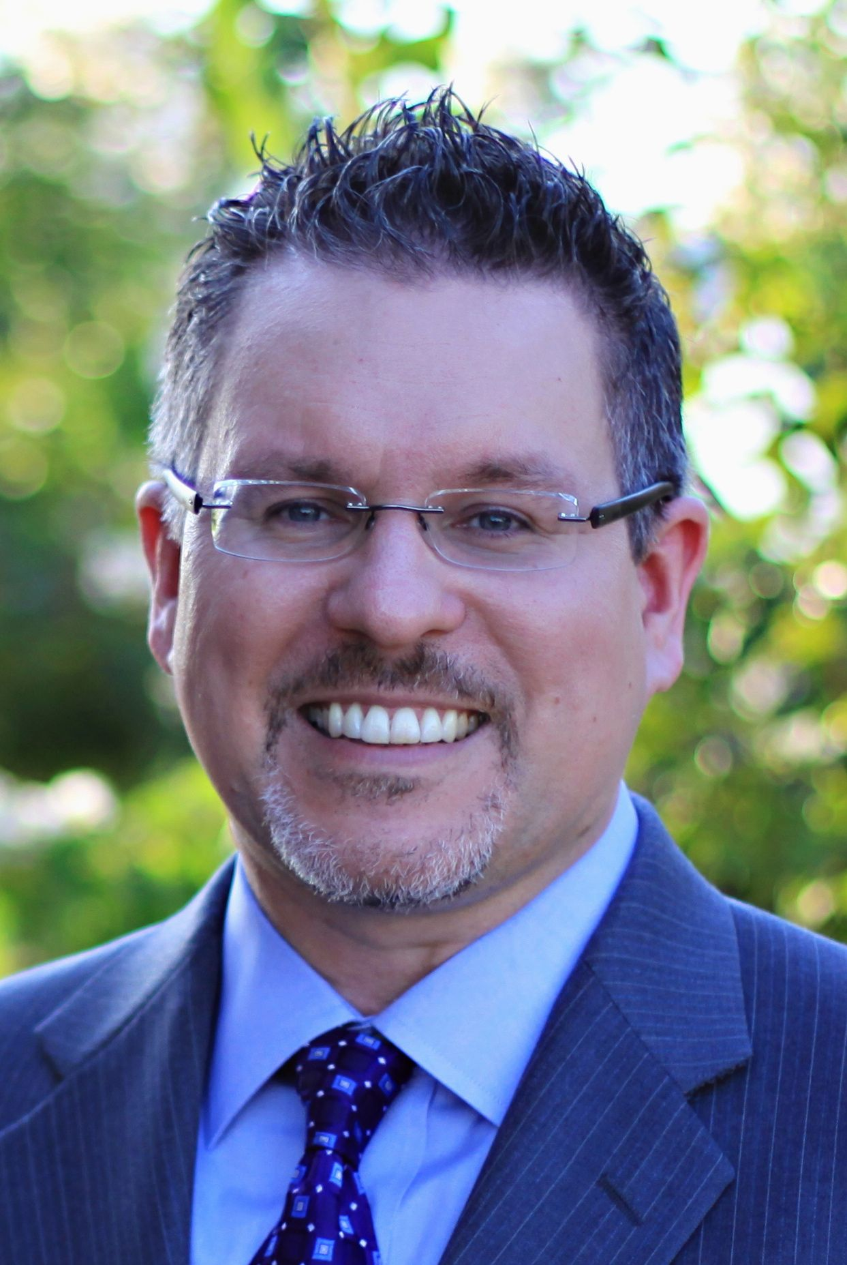
Mark Graban, MS, MBA
Author Bio

For more information, please contact:
Mark Graban
mark@constancy.us

Short Version
Mark Graban is the author of the Shingo Award-winning books Lean Hospitals: Improving Quality, Patient Safety, and Employee Engagement and Healthcare Kaizen: Engaging Front-Line Staff in Sustainable Continuous Improvements. He is also the founder of LeanBlog.org and Chief Improvement Officer of KaiNexus, a software startup. With a background in engineering and manufacturing, Graban has worked exclusively in healthcare since 2005 where he applies “lean” and Toyota Production System principles to improve quality of care and patient safety, to improve the customer/patient experience, to help the development of medical professionals and employees, and to help build strong organizations for the long term. For more information, please visit www.MarkGraban.com.
Long Version
Mark Graban is a consultant, author, keynote speaker, and blogger in the world of “Lean Healthcare.” In June 2011, Mark joined the software company KaiNexus as their “Chief Improvement Officer,” to help further their mission of “making improvement easier” in healthcare organizations, while continuing his other consulting and speaking activities.
He is the author of the book Lean Hospitals: Improving Quality, Patient Safety, and Employee Engagement (Productivity Press), which was selected for a 2009 Shingo Research and Professional Publication Award and is being translated into eight languages. A 2nd revised edition was released in November, 2011. Mark has also co-authored a new book, titled “Healthcare Kaizen: Engaging Front-Line Staff in Sustainable Continuous Improvements,” which was released in June 2012. He is the founder and lead blogger and podcaster at LeanBlog.org, started in January 2005.
Mark earned a BS in Industrial Engineering from Northwestern University as well as an MS in Mechanical Engineering and an MBA from the MIT Sloan Leaders for Global Operations Program (previously known as Leaders for Manufacturing). Mark has worked in automotive (General Motors), the PC industry (Dell), and industrial products (Honeywell). At Honeywell, Mark was certified as a “Lean Expert” (Lean Black Belt).
Since August 2005, Mark has worked exclusively in healthcare, where he has coached lean teams at client sites in North America and the United Kingdom, including medical laboratories, hospitals, and primary care clinics. From 2005 to 2009, Mark was a senior consultant with ValuMetrix Services, a division of Johnson & Johnson and he currently consults independently and in partnership with larger firms.
Mark’s motivation is to apply Lean and Toyota Production System principles to improve quality of care and patient safety, to improve the customer/patient experience, to help the development of medical professionals and employees, and to help build strong organizations for the long term.
From June 2009 to June 2011, Mark was a Senior Fellow with the Lean Enterprise Institute, a not-for-profit educational organization that is a leading voice in the Lean world. Mark served as the LEI’s “Chief Engineer” for healthcare activities, including workshops, web & social media, and other publications. Mark also served as the Director of Communication & Technology for the Healthcare Value Network, a collaboration of healthcare organizations from across North America, a partnership between LEI and the ThedaCare Center for Healthcare Value. Mark continues as a faculty member for LEI and the ThedaCare Center.
Mark is a popular speaker at conferences and private healthcare meetings. He has guest lectured at schools including MIT, The Ohio State University, and Wharton and has served as a faculty member for the Institute for Healthcare Improvement. He has been quoted and interviewed in many publications, including Health Affairs and the New York Times.

# # #

